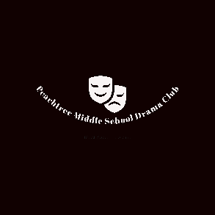
PCMS Drama Club

Sponsorship Opportunities
2019 - 2020
Purpose
The Peachtree Charter Middle School (PCMS) Drama Club is a self funded, non-profit 501 (c) (3) organization that relies solely on student dues and sponsorship opportunities to provide arts education for PCMS drama students and produce an annual musical.
Approximately 80 students and their parents benefit from participating in our theatre arts education program and be part of a full-scale production. Our goal is to build confidence, inspire a life long appreciation for theatre and creativity, develop cross grade friendships and mentoring, encourage pride in self, school and community and most importantly to HAVE FUN!!
Our drama club exposes our students to more than just acting. They also receive hands on experience in costume design, choreography, music, stage management, design, technology and building communication skills. Any student who would like to be involved in our club is most welcome regardless of financial status or if they have any special needs. We are an all inclusive club!!
We need your help! At What Level Can You Participate?
Benefactor - $1000
Your sponsorship entitles you to a full page ad in our playbill, a banner ad on our webpage, be the ‘featured sponsor of the month’ on our Facebook page, 4 VIP tickets to our Spring production of Willy Wonka Jr and 2 show T-shirts.
Producer - $500
Your sponsorship entitles you to a half page ad in our playbill, a banner ad on our webpage, be the ‘featured’ sponsor of the month on our Facebook page and 2 VIP tickets to our Spring production of Wily Wonka Jr.
Agents - $250
This level includes a half page ad in our playbill, a small banner ad on our webpage and 2 tickets to the Spring Production of Willy Wonka Jr.
Master Thespian - $150
This level includes a ¼ page ad in our playbill and 2 tickets to our Spring Production of Wily Wonka Jr.
Family Sponsor - $100
Your family name (or a name you choose) will be mentioned on our webpage and you will also receive early access to tickets on your choice of night to the show.
All donations are tax deductible through the PCMS Booster Club’s 501 (c) (3) non profit corporation status. EIN # 27-4318969. For further information please contact us at pcms_drama@yahoo.com

